Sunday, September 13, 2009
Dear ,

On behalf of the Historic Staunton River Foundation, I would like to invite you to the Foundation’s Annual Meeting on Thursday, October 1 to be held in the Clover Visitors Center Conference Room promptly at 6:00 P.M. The Foundation has been hosting a “annual” meeting for its members, donors, and volunteers for several years. All have proved to be successful with a delicious meal, interesting speakers and lecturers, door prizes, recognitions, and reports of the life and sustainability of the Foundation and Park. Please consider attending this event, and we urge you to bring a friend or a guest who is not already a member of the Foundation. Currently, we are trying to build our membership and increase the awareness of the Park.

Supper for the Annual Meeting will be available; however, in order to feed all those present (members, Park staff, and guests) we are asking ALL in attendance to bring a covered dish (vegetable, salad, bread, or dessert). The meats (ham and fried chicken) and all paper products will be furnished by the Foundation.

Following the meal, local historian, musician, and re-enactor, Tom Ward, will speak on the subject of Civil War music. Mr. Ward, a native of Halifax County, is a member of Confederate re-enactment group, 14th Virginia Infantry, Co. K. In addition, Mr. Ward is a passionate and gifted musician. He is no stranger to the Park, as he has avidly supported and attended every event from the June Commemoration to the Haunted Harvest Hayride to the Antebellum Christmas Open House – all the while in uniform with banjo in hand.

At the conclusion of Mr. Ward’s speech, several brief reports relation to the Foundation and Park will be presented, and nominations to the Foundation’s Board of Trustees will be approved by its membership. I hope you will consider attending the Annual Meeting, not only to enjoy good food and fellowship, but also to hear an extraordinary guest and become more conscious of the status of the Foundation and the Staunton Rive Battlefield State Park.

If you have any questions, please feel to email info@stauntonriverbattlefield.org or call 434-454-7157. I hope to see you at the Park,

Regards,

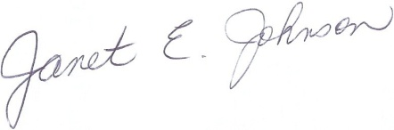
Janet E. Johnson
President
Board of Trustees
Historic Staunton River Foundation, Inc.

