Tuesday, August 16, 2011
Dear,

On behalf of the Historic Staunton River Foundation, I would like to invite you to attend the Foundation’s Annual Meeting on Thursday, September 6 to be held in the Roanoke Station Visitors Center (Randolph on the Charlotte County side) promptly at 6:00 P.M.
For several years now, the Foundation has been hosting an “annual meeting” for its members, donors, supporters, Park staff, and volunteers. All have proved to be quite successful and well received with a delicious meal, interesting speakers and lectures, door prizes, special recognitions, and reports of the life and sustainability of the Foundation and Park.
As a loyal member, donor, supporter, or volunteer of the Foundation, please consider attending this event, and I welcome you to bring a friend or a guest, who are interested in the Foundation, Park, Staunton River, Mulberry Hill, Staunton River Bridge, Walking Trails, Wildlife, War Between the States, Native Americans, Archaeology, Genealogy, or History. There is so much to see, learn, smell, hear, touch, and love at our Park. We continue to build our membership and increase awareness of the Foundation’s mission and goals!
Supper for the Annual Meeting will be available; however, in order to feed all those present (members, Park staff, friends, and guests), we are asking any and all in attendance to bring a covered dish (vegetable, casserole, salad, bread, or dessert). As with tradition, the meats (ham and fried chicken), beverages, and all paper products will be furnished by the Foundation or the Board of Trustees.
Following the meal, Dr. Bill Trout, the author of the Staunton River Atlas, will be our guest speaker. His presentation will focus on the unique aspects of the 381-mile stream of the Staunton River from its trickling beginnings in the foothills of Montgomery County down to Albemarle Sound on the Atlantic coast in North Carolina. He will also highlight the history and the attempts to navigate its waters. Copies of his Atlas will be available for purchase, along with several limited-edition-numbered autographed copies. Please purchase one and have Dr. Trout autograph it! Our guest speaker is trained as an architectural historian and a graduate of Virginia Commonwealth University and the University of Richmond. He is a resident of Richmond. He is the author of one book and many articles on the architecture of his native city. Formerly the Archivist for Architectural Records at the Library of Virginia, Richardson is involved with several preservation groups to save some of Richmond's historic buildings. He lives with his wife, Karri. Their daughter, Lelia, is named after her great-great-great grandmother, Lelia Farinholt, who was Col. Farinholt's wife.
At the conclusion of Dr. Trout’s presentation, several brief reports from the Board of Trustees and Park will be presented and nominations to the Board of Trustees will be made and approved by the Foundation’s membership. I hope you will make plans to attend our Annual Meeting, not only to enjoy good food and fellowship, but also to hear an extraordinary guest speaker, an authority on the Staunton River and its unique history and forms; and become more conscious of the status of your Foundation and the Staunton River Battlefield State Park.
If you have any questions, please email info@historicstauntonriverfoundation.org or phone 434.454.7157. Please remember to visit our website (www.historicstauntonriverfoundation.org), and “Like Us” if you are on Facebook (search for Historic Staunton River Foundation). I hope to see you at the Park!

Regards,
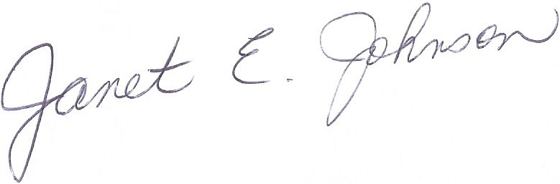
Janet E. Johnson
President

